TASK-1
The Backbone: Your Internet service arrives via a coaxial cable to the Modem, which then passes the connection to the Wireless Router.
Wired Connections: The Router is connected to a 8-Port Network Switch, which acts as a hub to connect wired devices like a Desktop PC.
Wi-Fi Expansion: To extend coverage, a separate Wireless Access Point is connected to the switch via Ethernet.
Wireless Devices: I have included a Laptop connected to the main router and a Smartphone connected to the extended access point.
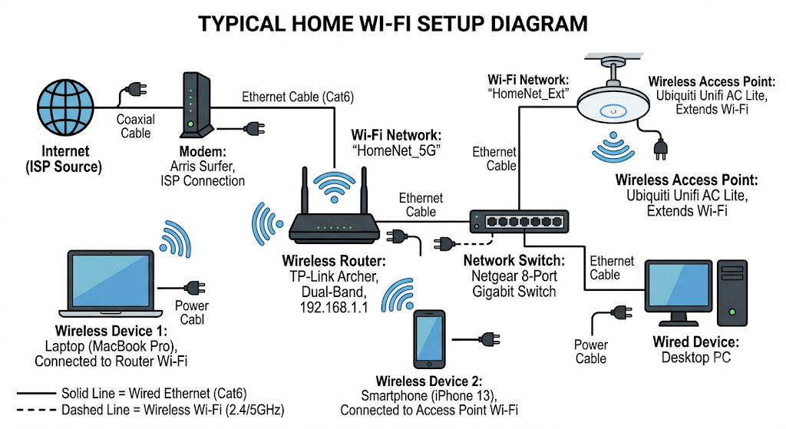

TASK-2
- Modem: Connects your home to the internet.
  - Example: The main box from your internet provider.
- Router: Shares that internet connection with your devices and directs traffic.
  - Example: Your home Wi-Fi box.
- Switch: Connects multiple wired devices together.
  - Example: Wiring dozens of computers together in an office or school lab.
- Access Point: Adds or extends Wi-Fi coverage.
  - Example: Ceiling Wi-Fi antennas in airports or hotels.
- Network Cable: The physical wire that connects devices.
  - Example: Plugging a computer directly into the router for a faster, stable connection.

TASK-3
1. Ethernet Cable (RJ45)
Common Use: Connects computers, gaming consoles, and routers within a local network for fast, reliable wired internet.
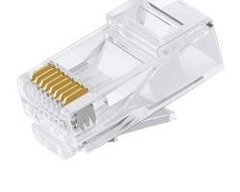
2. Coaxial Cable
Common Use: Connects wall outlets to cable modems and set-top boxes to deliver television signals and high-speed cable internet into homes.
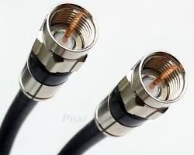
3. Fiber Optic Cable
Common Use: Uses light signals to deliver ultra-high-speed internet connections over long distances between internet providers, data centers, and fiber-to-the-home setups.
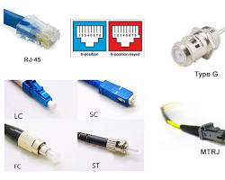
TASK-4
Feature / Difference | Router | Switch
Main Use | Connects different networks together (e.g., connects your local home network to the internet). | Connects multiple devices together within the same local network (LAN).
Typical Location | At the boundary/edge of a network, positioned between the modem and the local network. | Inside the local network, connected between a router and wired devices (like PCs, printers, and servers).
How Data is Handled | Reads IP addresses to route data packets between different networks using the best path. | Reads MAC addresses to forward data frames directly to the specific destination device on the local network.
OSI Model Layer | Works at Layer 3 (Network Layer). | Works at Layer 2 (Data Link Layer).
Typical Port Count | Usually has few ports (2 to 5 Ethernet ports on standard models). | Has many ports (commonly 8, 16, 24, or 48 ports for expanding wired connections).

